**137. Retrieving Query Parameters and Fragments**

* -: In the last lecture we learned how we can pass query parameters and fragments.
* Now let's make sure we can all retrieve them.
* So we're loading this added server component in the end.
* So that is probably where we want to retrieve that information.
* We can easily do this by going there, added server component.
* And you see there already is a lot of code in there.
* Well, everything, what's happening here, however is it's using our service service to get the server with the ID one and to be able to update it.
* And definitely dive into this service, service file.
* If you want to learn more about what's happening here, it's super simple though.
* We simply are able to get this array of servers get a single server or update a single server.
* So override it.
* So that's not the interesting part.
* The interesting part in the added server component here is how we can get access to our query parameter and the fragment.
* We need our activated route for this so let's inject it just like we did before.
* Activated route needs to be imported from the @AngularRoute package.
* So make sure to add this import at the top.
* And with this added and let's say ngOnit, we can retrieve our query parameters and the fragment.
* ***And just like before, there are two ways of retrieving it.***
* ***For the first approach we can simply access the snapshot of our route, and access query Param here,*** or our fragment, just like that.
* *Now this might bring the same problem as with the Param.*
* *This is only run or updated at the time this component is created.*
* So if there is a chance of changing your query Param from the page you're currently on you might not want to use this approach because it won't be reactive, it won't display or allow you to react to any changes which have after this component has been loaded.

* So for now, let's use this snapshot though and let's watch the console.
* Once this reloads, notice we already have a query parameter and a fragment, and we see both here.
* This is our query parameter object where we have this key value pair mapping again, allow added to one.

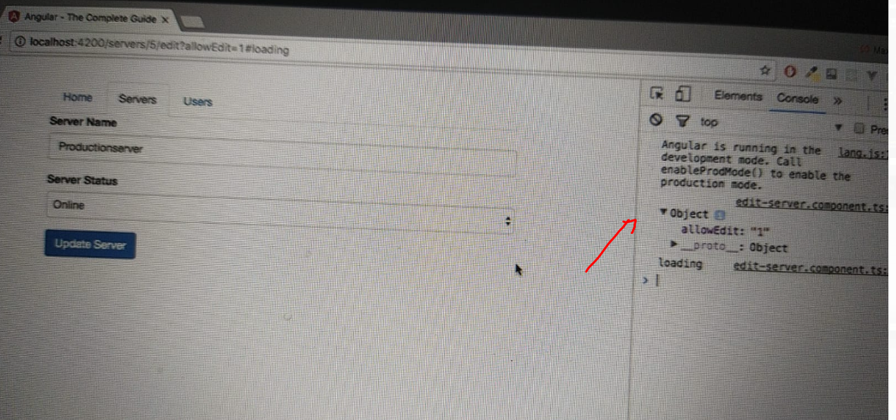

* And this is just a bit broken but here you see if I make my console a bit broader you see the loading hash fragment.
* So this is how you can retrieve it.
* **The alternative, of course is to use the route** and just like we had Param as observable, we also have query Param as an observable, we can subscribe to like this.
* And of course we also have fragment as an observable we can subscribe to.
* So just like before, this will now allow you to react to change query parameters.
* Now that's something we will use later in this module.

* For now, nothing will happen here but it is important to keep in mind.
* Like for prayer Param you do have the same for query Param and fragment.
* You don't need to unsubscribe here.
* Angular will handle it for you just like it did for Param.
* But this is how you can now get access to these extra features and how you can make sure that you don't miss the data.